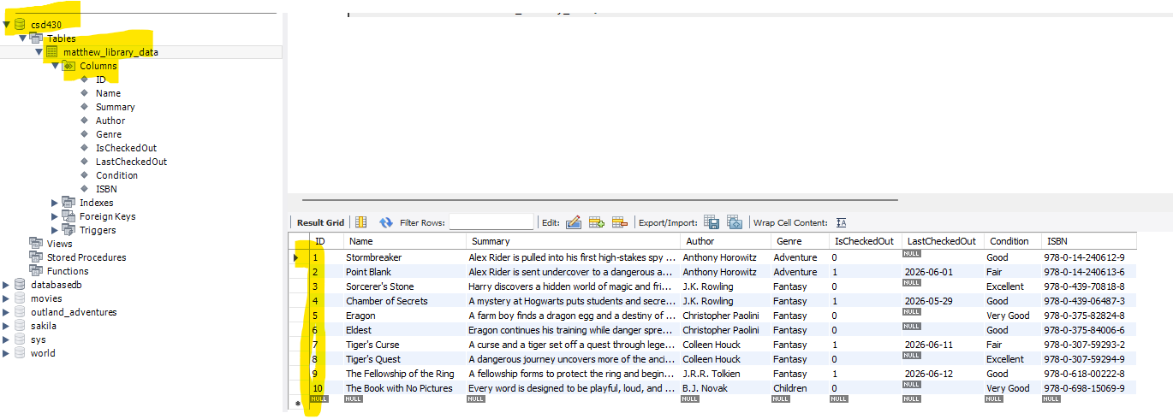

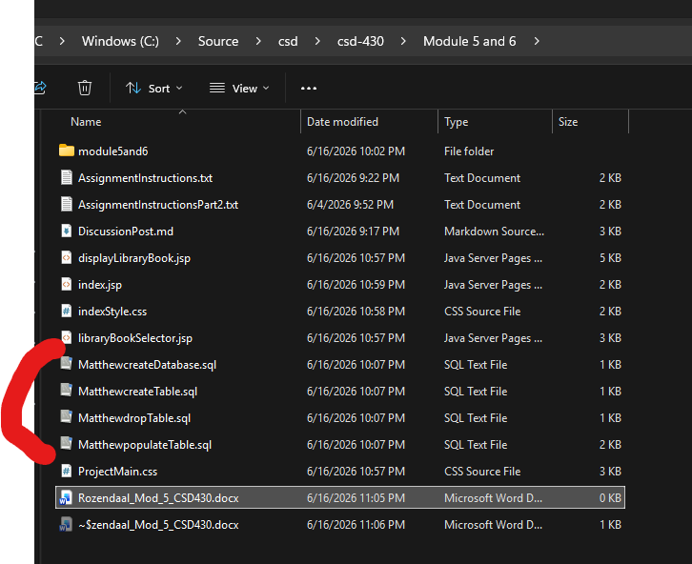

I included the Create database as well since I felt it was implied to be included. But it shouldn’t really be included in with Create Table in my mind.

